Logical Plan vs Physical Plan
Logical Plan
- Describes what operations need to happen.
- Similar to relational algebra.
- Independent of implementation.
Physical Plan
- Describes how each operation will be executed.
- Chooses actual algorithms like:
  - Hash Join
  - Merge Join
  - Nested Loop Join
  - Sequential Scan
  - Index Scan
A single logical plan can have many physical implementations.

Relational Algebra Equivalence
Many relational algebra expressions produce exactly the same result.
The optimizer rewrites queries into equivalent but faster forms.

Types of Query Optimization
1. Rule-Based (Heuristic)
Uses fixed optimization rules.
Examples:
- Push selections down
- Perform projections early
- Replace Cartesian products with joins
Pros:
- Fast
- Simple
Cons:
- Doesn't always produce the best plan

2. Cost-Based Optimization
The optimizer:
- Generates multiple equivalent plans.
- Estimates the execution cost of each.
- Picks the cheapest one.
Modern DBMSs mainly use this approach.

Logical Query Optimization
These transformations happen before cost estimation.
Important rules:
Predicate Pushdown
Apply filters as early as possible.
Reorder Predicates
Evaluate the most selective condition first.
Split Complex Predicates
Break large conditions into smaller ones so each can be pushed closer to the data.
Projection Pushdown
Only keep the columns needed.
Instead of carrying every column through joins, remove unnecessary columns early.
Benefits:
- Smaller tuples
- Less memory usage
- Faster joins

Cost Estimation
The optimizer estimates the cost of each plan instead of executing it.
Main cost factors:
- CPU
- Disk I/O (most expensive)
- Memory
- Network communication
The optimizer stores table statistics to estimate these costs.

Search Termination
The optimizer cannot search forever.
It stops when one of these conditions is met:
- Time limit reached
- Cost is already good enough
- All plans explored
- Maximum number of transformations reached

Access Path Selection
The optimizer chooses the best way to read a table.
Possible choices:
- Sequential Scan
- Index Scan
- Binary Search
Factors affecting the decision:
- Predicate selectivity
- Available indexes
- Sort order
- Compression
- Extra index features (e.g., INCLUDE columns, zone maps)

Single-Relation Query Planning
Only one table is involved.
Main decision:
Which access method is cheapest?
For OLTP workloads, this is usually easy because queries are sargable (Search Argument Able), meaning an index can efficiently answer the query.

Multi-Relation Query Planning
When many tables are joined, the number of possible plans grows rapidly.
The optimizer must decide:
- Join order
- Join algorithm
- Access method for each table
Searching every possible plan is too expensive.

Two Optimization Strategies
Bottom-Up (Generative)
Starts with individual tables.
Gradually combines them into larger plans.
Uses BFS.

Top-Down (Transformational)
Starts with the final query result.
Works backward to find better implementations.
Uses DFS.

Bottom-Up Optimization (System R)
Steps:
- Apply simple heuristic rules.
- Generate logical operators.
- Generate possible physical operators.
- Use dynamic programming to find the cheapest join order.
- Build mostly left-deep join trees.

Enforcers
Sometimes an operator requires a certain property.
Example:
ORDER BY name
If the input is not sorted, the optimizer inserts an enforcer.
Example enforcers:
- Sort
- Quicksort
They guarantee required output properties without changing query results.

Star/Snowflake Query Optimization
For data warehouse queries:
- Join the fact table with dimension tables.
- Use left-deep or right-deep join trees.
- Join the most selective dimension tables first.
- Avoid exploring unnecessary bushy trees.
This significantly reduces the search space.
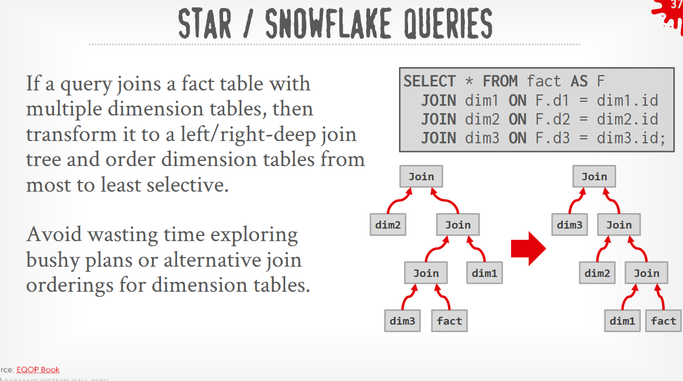

Nested Subquery Optimization
Instead of executing nested queries repeatedly, the optimizer tries to:
1. Flatten (Decorrelate)
Convert subqueries into joins.
2. Decompose
Execute the subquery separately, store the result temporarily, then use it in the main query.
Both approaches usually improve performance.

Expression Rewriting
The optimizer simplifies expressions before execution.
Process:
- Match a known pattern.
- Rewrite into a simpler equivalent expression.
- Repeat until no more rules apply.

Common Expression Rewrites
Impossible Predicates
WHERE 1 = 0
Optimizer immediately knows no rows can match.

Merge Redundant Predicates
simplify to the minimum equivalent condition.
This reduces unnecessary work during execution.
